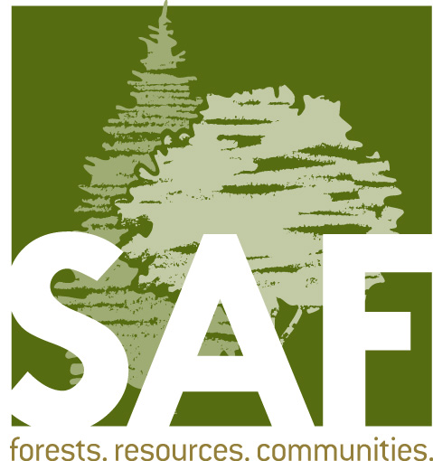

Fellow Endorsement Form

Nominations are due March 1

Each nomination packet must include three endorsement forms completed by three different individuals.

Please note: Information may be provided separately if additional space is required.
Fellow Nominee:
Endorser Contact Information:
Endorser name:
Address:
City: State: ZIP Code:
Day Phone : Email:

Criterion #1 - Commitment to SAF

- Provide specific examples that demonstrate the nominee’s commitment to SAF voluntary activities in two or more of the following SAF organizational levels: local (chapter); state; regional (multi-state or voting district); or national. Examples should include as much detail as possible to demonstrate the nominee’s involvement in each activity or project.

- Provide information on how SAF benefited from the nominee’s involvement in these activities or projects. Please be as specific as possible and include any and all short-term and long-term impacts to SAF.

Criterion #2 – Exemplary Action

Please select the professional activity in which the following information will cover

Application of Forestry Education Public Policy Research Technology Transfer

- Provide specific examples of the nominee’s involvement in activities or projects that advance the forestry profession at two or more of the following levels: local; regional; national; or international. Examples should include as much detail as possible regarding the nominee’s involvement or accomplishments in these activities or projects.

- Provide information on how the forestry profession benefitted from the nominee’s action or leadership in the above activities or projects. Please be as specific as possible and include all short-term and long-term impacts to forestry.

Additional Information
Please add any additional information regarding the nominee’s involvement which will assist in evaluation for Fellow.

